Lab No.: Lab-2
Lab Aim and Objective: To develop a Linear Regression model for predicting house prices using suitable dataset.
Dataset or resources used: USA_Housing.csv, Python, Jupyter Notebook, Pandas, Numpy, Matplotlib, Seaborn, Scikit-Learn.
Date of Performance: 23 July 2026

1. Theory based on the lab objectives
Linear Regression is a fundamental supervised machine learning algorithm used for predicting a continuous numerical target variable based on one or more predictor variables. The objective is to establish a linear relationship between the input features and the output variable.
1. Simple Linear Regression: Involves only one independent variable (e.g., Average Area Income) to predict the dependent variable (House Price). The model fits a straight line (y = mx + c) that minimizes the sum of squared differences between actual and predicted values.
2. Multiple Linear Regression: Involves multiple independent variables (e.g., Income, Age of House, Number of Rooms) to predict the target. It forms a hyperplane in multi-dimensional space to capture the combined effect of all features.
3. Regularization Techniques: To prevent overfitting and handle multicollinearity, regularization techniques like Ridge (L2) and Lasso (L1) regression are used. Ridge adds a penalty equal to the square of the magnitude of coefficients, shrinking them but rarely to absolute zero. Lasso adds a penalty equal to the absolute value of the magnitude of coefficients, which can lead to sparse models by completely eliminating less important features.
4. Model Evaluation: The performance of regression models is evaluated using metrics like Mean Absolute Error (MAE), Mean Squared Error (MSE), Root Mean Squared Error (RMSE), and the R-squared (R) score, which indicates the proportion of the variance in the dependent variable that is predictable from the independent variables.

2. Written code uploaded to GitHub
The written code for this practical is uploaded and available at the following GitHub URL:
https://github.com/NodeNexus/MachineLearningProjects

3. Procedures and materials used
Materials Used:
- Hardware: Standard PC/Laptop
- Software: Windows OS, Python 3, Jupyter Notebook
- Libraries: Pandas (Data handling), Numpy (Math), Matplotlib & Seaborn (Visualization), Scikit-Learn (Modeling and metrics).
Procedures:
1. Imported pandas and loaded the 'USA_Housing.csv' dataset. Removed non-numeric columns like 'Address'.
2. Conducted Exploratory Data Analysis (EDA) using info(), describe(), and plotted a correlation heatmap to identify highly correlated features with 'Price'.
3. Visualized the distribution of features like 'Avg. Area Income' using histograms and density plots.
4. Implemented Simple Linear Regression using 'Avg. Area Income' to predict 'Price', splitting the data 80/20 for training and testing.
5. Evaluated the Simple Linear Regression model using MAE, MSE, RMSE, and R2 score, and plotted the regression line against the actual test data.
6. Implemented Multiple Linear Regression using all available numeric features to predict 'Price'.
7. Evaluated the Multiple Linear Regression model and visualized the predicted versus actual prices using a scatter plot.
8. Applied Ridge Regression (L2 regularization) and optimized the 'alpha' hyperparameter using GridSearchCV.
9. Applied Lasso Regression (L1 regularization) similarly using GridSearchCV to observe the impact on feature weights.
10. Created interactive inputs for dynamic predictions based on custom user data.

4. Output screenshots with proper descriptions
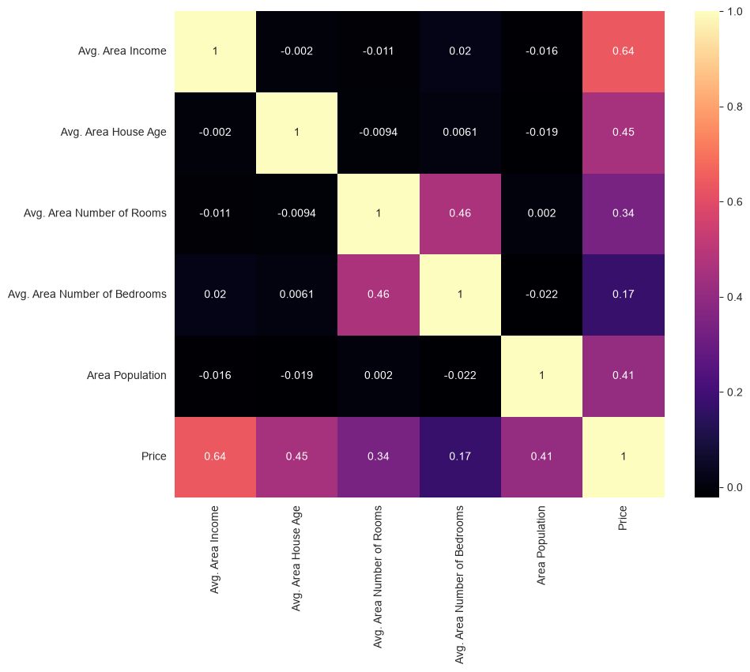
This correlation heatmap visualizes the linear relationships between all numeric variables in the USA Housing dataset. The 'Avg. Area Income' exhibits the strongest positive correlation (0.64) with the target variable 'Price', suggesting it is the most influential predictor. Other features like 'Avg. Area House Age' and 'Avg. Area Number of Rooms' also show moderate positive correlations with the house price.

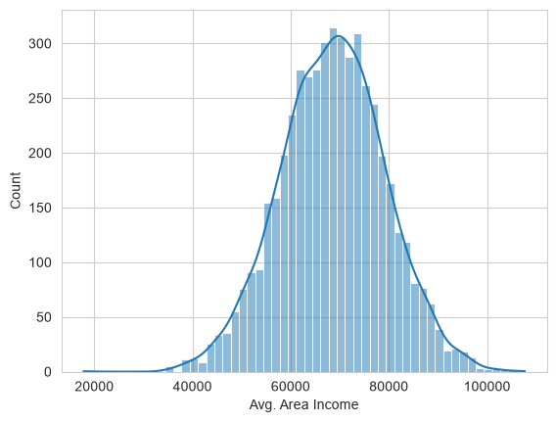
This histogram with a Kernel Density Estimate (KDE) curve illustrates the distribution of the 'Avg. Area Income' feature. The distribution is nearly perfectly normal (bell-shaped), centered around $68,000. This normality in the independent variable is highly beneficial for linear regression models, as it helps satisfy the assumption of normally distributed data and residuals.

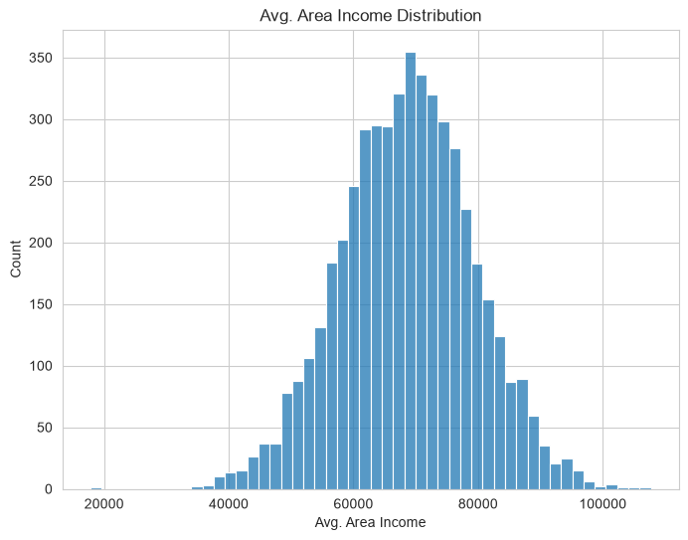
This plot further visualizes the distribution of the average area income across the dataset using discrete bins. It reinforces the observation of a normal distribution with the highest frequency of occurrences near the mean value. There are very few extreme outliers on either the lower end ($20k) or the higher end ($100k), indicating a well-balanced sample of housing data.

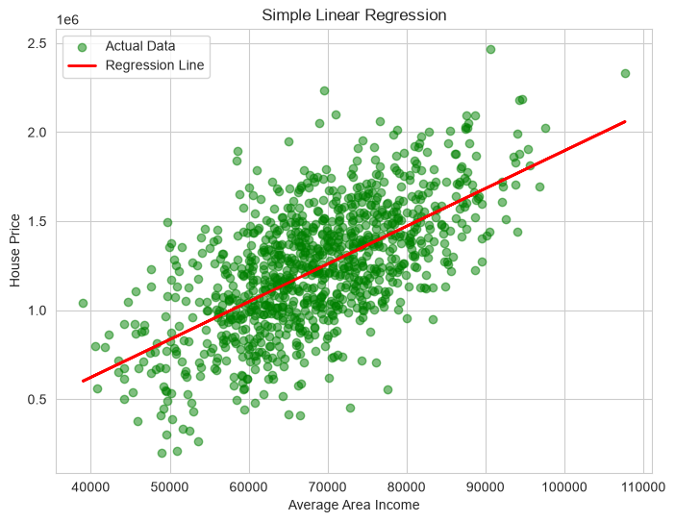
This scatter plot visualizes the results of the Simple Linear Regression model. The green dots represent the actual test data points (Income vs. Price), while the red line represents the best-fit regression line generated by the model. The line clearly captures the positive linear trend, showing that as average area income increases, the predicted house price predictably increases along the line.

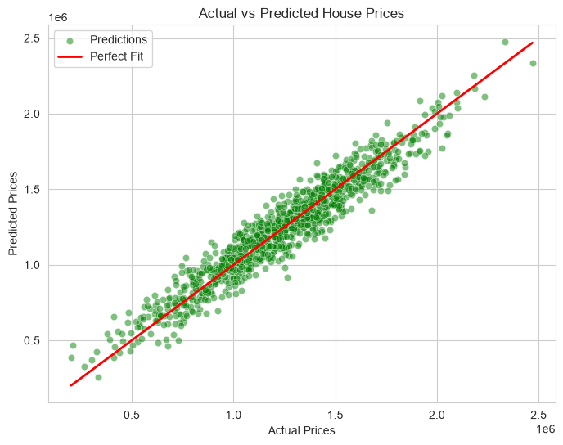
This scatter plot evaluates the performance of the Multiple Linear Regression model by comparing the actual house prices (x-axis) against the model's predicted prices (y-axis). The red line represents a 'perfect fit' where predicted equals actual. The tight clustering of the green data points along this red diagonal line indicates that the model has high accuracy and a strong R-squared value.

5. Viva Questions
Q1. What is the fundamental difference between Simple Linear Regression and Multiple Linear Regression?
Ans: Simple Linear Regression uses only one independent variable (feature) to predict a single dependent variable, resulting in a straight line fit. Multiple Linear Regression uses two or more independent variables to predict the dependent variable, fitting a hyperplane in a multidimensional space to capture complex relationships.
Q2. Why do we use train_test_split, and what does the random_state parameter do?
Ans: We split data into training and testing sets to evaluate how well the model generalizes to unseen data, preventing overfitting. The training set is used to build the model, while the testing set evaluates it. The 'random_state' parameter sets a seed for the random number generator, ensuring that the data split is reproducible and yields the exact same subsets every time the code is run.
Q3. What is the R-squared (R2) score, and what does a value closer to 1 signify?
Ans: R-squared (Coefficient of Determination) is a statistical measure that represents the proportion of the variance in the dependent variable (target) that is explained by the independent variables (features) in the model. A value closer to 1 (or 100%) signifies that the model perfectly explains the variability of the response data around its mean, indicating a highly accurate fit.
Q4. When and why should we use Ridge or Lasso Regression instead of standard Multiple Linear Regression?
Ans: Ridge (L2) and Lasso (L1) regressions are used when the model suffers from overfitting or multicollinearity (high correlation between independent variables). They apply regularization penalties to the coefficients. Ridge shrinks coefficients evenly, while Lasso can shrink some coefficients completely to zero, effectively performing feature selection by eliminating less important features.
Q5. What information does the correlation heatmap provide before training the model?
Ans: The correlation heatmap visually represents the Pearson correlation coefficients between all pairs of numeric variables. It helps identify which features have the strongest linear relationship with the target variable (highly predictive features) and highlights multicollinearity (highly correlated independent features), guiding feature selection and engineering prior to model training.

